Guidance for Topic 4 DQ 1
There are two tabs on this sheet. Part of the Purpose is to practice linking to a different tab. Note that the exact cell references shown in the images might differ from the current template.

Budget Tab
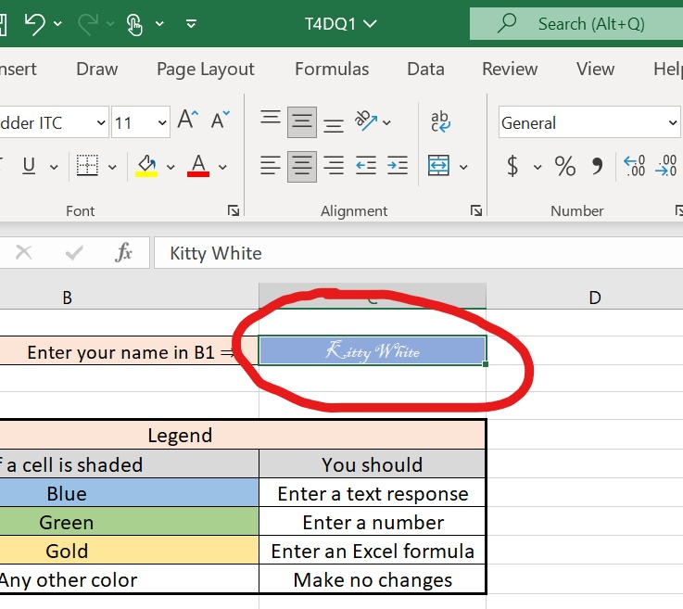
- As always, enter your name in C2.

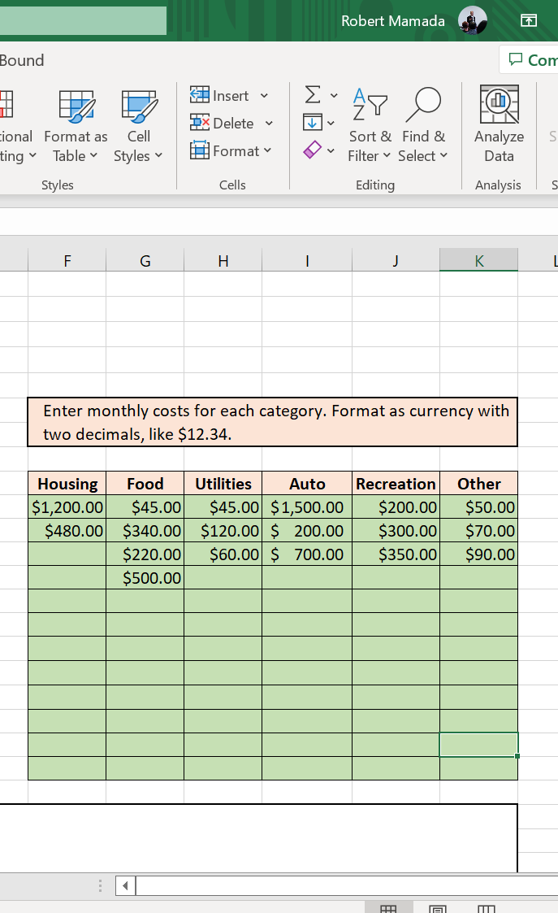
- Enter your expenses. They don’t have to be your real expenses. Rough estimates are fine.

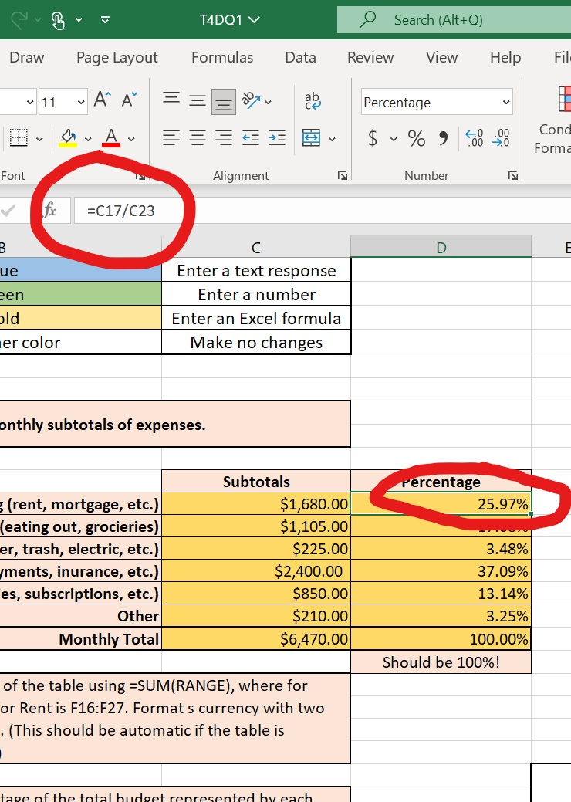
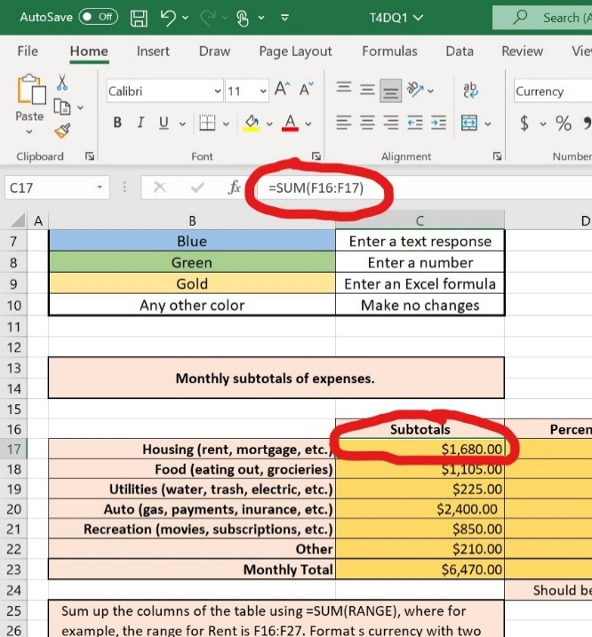
- Here is an example of how to enter the formulas.
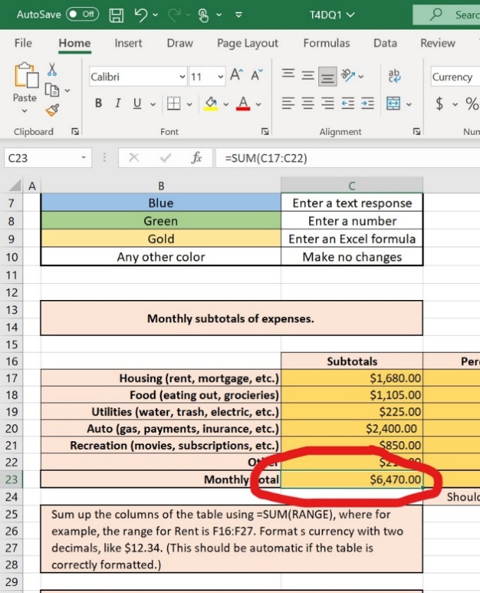

Make sure to use “Format cells” to get the numbers in percentages.
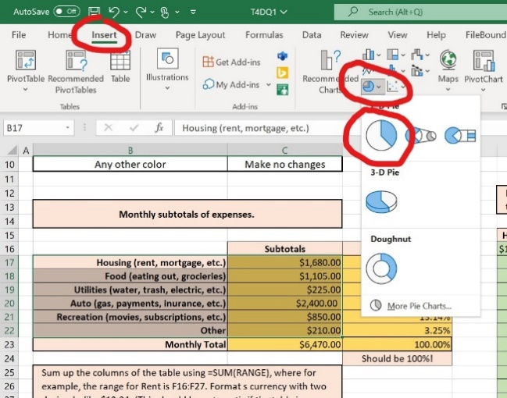
- Highlight the names of the categories and “subtotals” or “percentage” (from rows 17 to 22). Then, click “Insert” and choose “Pie chart.”

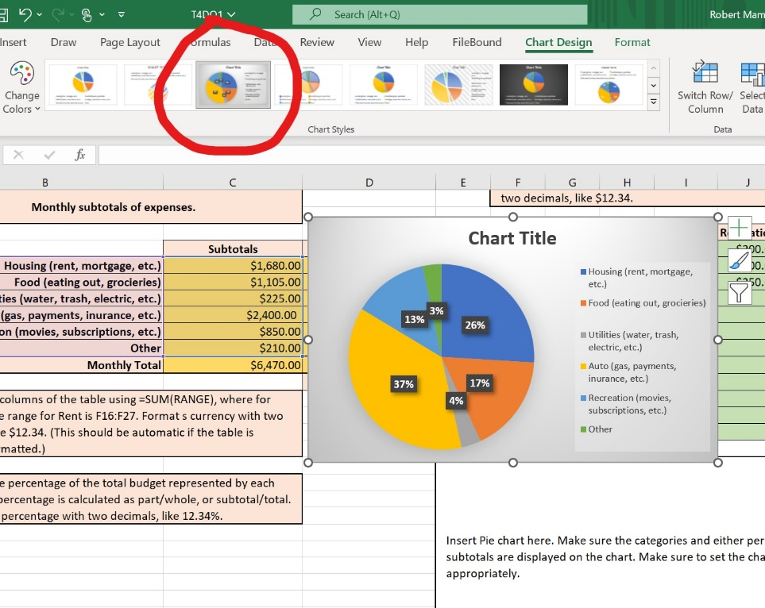
- Once the pie char appears, click the pie chart and choose the option in the red circle. You can change the title of the chart by clicking it.

- The procedure for creating a bar chart is similar with the one for the pie chart.

Percent Change Tab
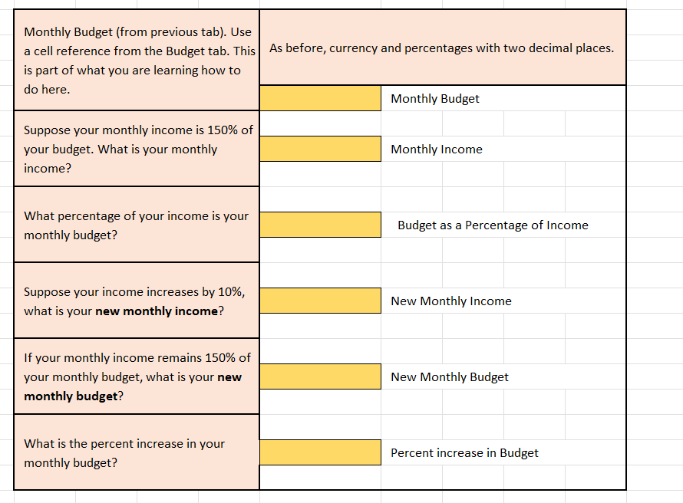
Use a cell reference for your monthly budget from the Budget sheet. You can enter “=” and then, with your mouse, select the correct cell from the budget sheet, or you may type in “=Budget!C23.” (This is the only new skill here.)

Percentage and percent change has already been covered in Topic 2, use what you know to complete the tab.

